DMWA Lab -3

Q1

1. Add Attribute

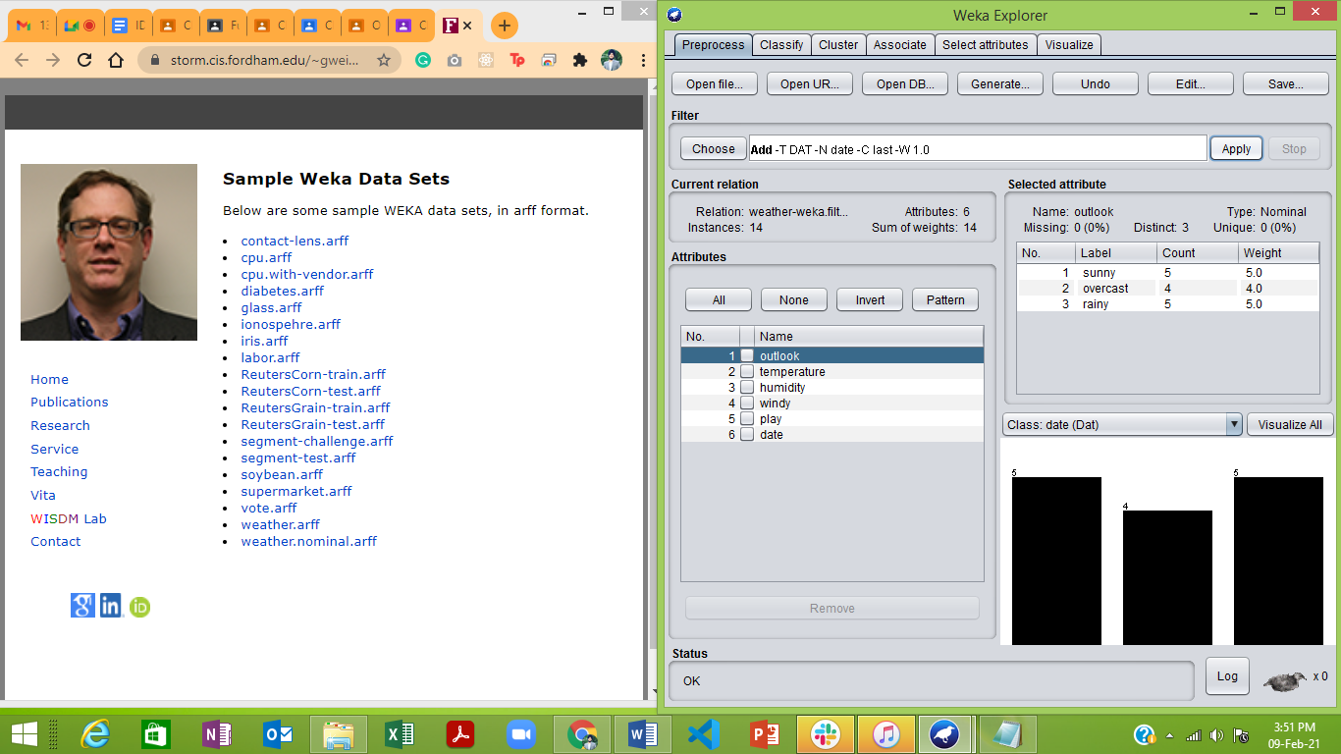

1. Removing the Attribute

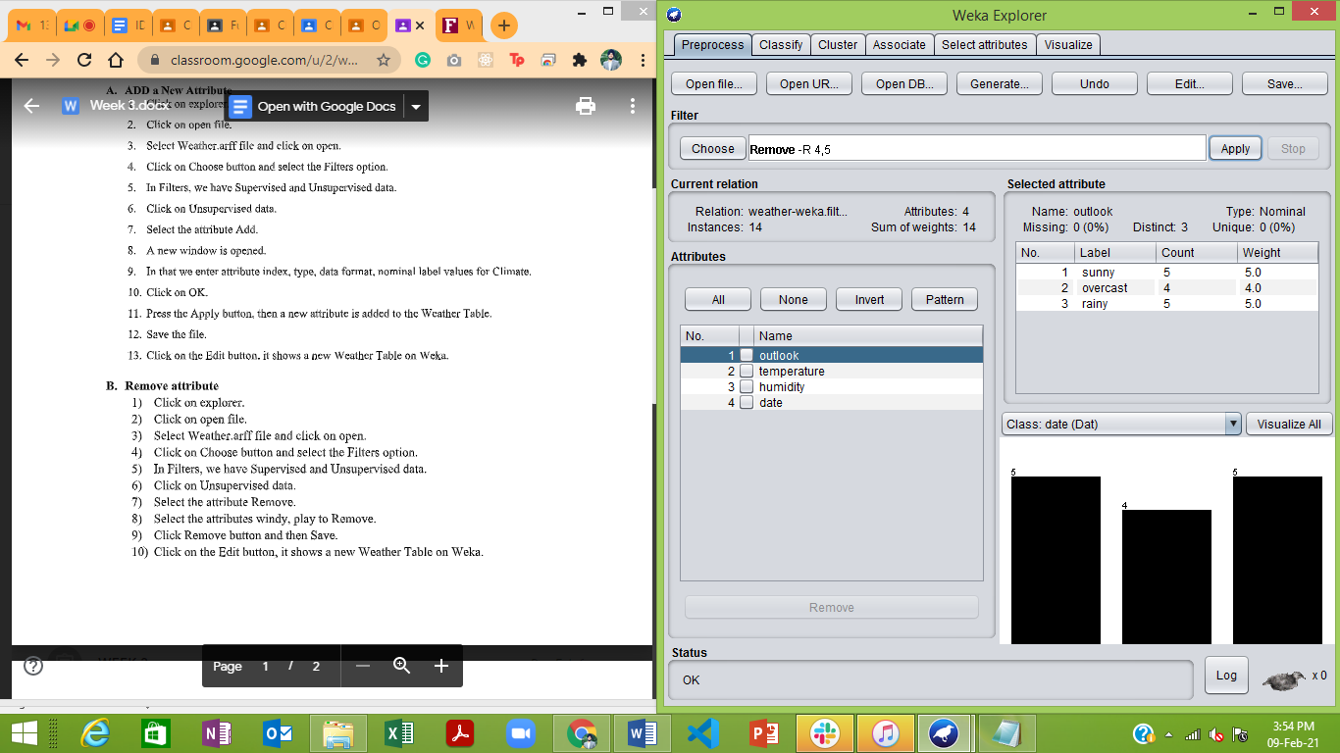

1. Normalizing the Data

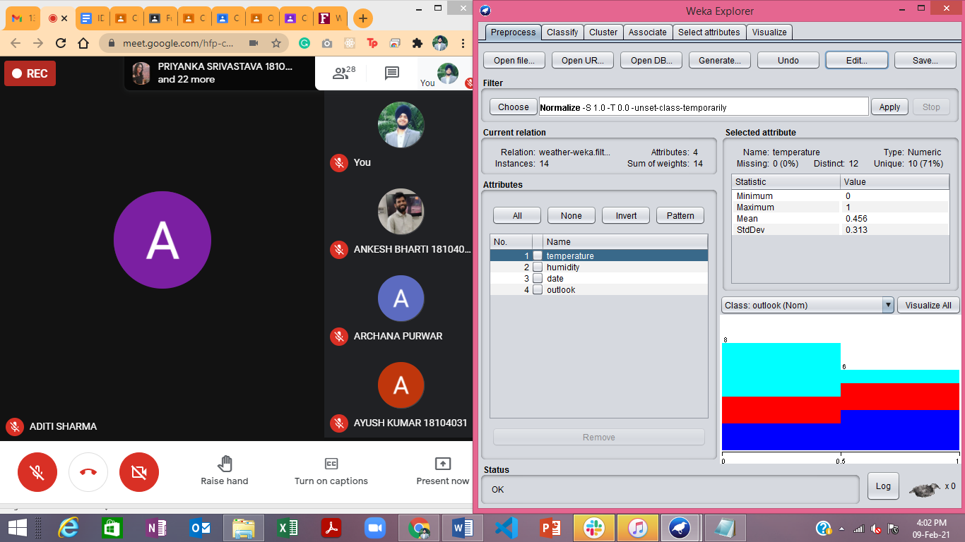

**Q2.**

1. Removing the Values in the dataset where petalWidth = 1.4

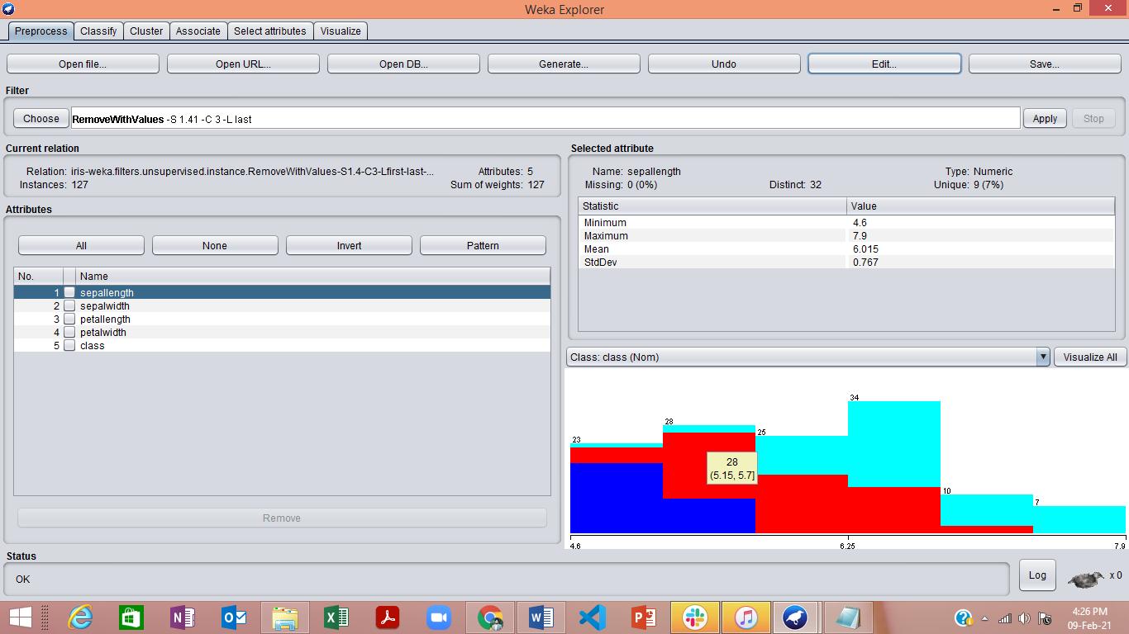

1. Applying Various Discretization Filters on the Dataset

